**Criteria 1**

**Design Problem/Situation/Opportunity/Need:**

Massive and heavy battle bots are very common mainly the mass is comprised in the weapon system then comes problems such as efficiency of mobility and weapons system which creates the need for lighter and faster battle bots. Which has problems that need to be tackle such as lack of weaponry and ease of access for damage to essential parts of the system which can lead to explosion of battery or damage to movement which is the problem in the need for a lighter and smaller battle bot system.

Design Brief:

To solve the problem of weak armor and lack of fire power for a light weight, small bot. I will need to develop a system that will be reliably strong and light that outperform other bots in these criteria while also operating and used in high-risk environments as it must be to with stand tons of force per m^2.

Design Brief Response:

To provide prototype solution to this problem, I will develop system that will be light weight using either light metal or light hard plastic base for it while maintaining speed with a 14v battery hooked up to two motors controlling the system.

Influenced Factors:

I originally was going to make the vehicle move like a tank with tanks tracks and 4 gearboxes’ but opted for a two gearbox with 3D printed wheels and rolling marble for the front design as it can move faster with this design and won’t require a lot of power to run.

**Evaluation Criteria:**

|  |  |  |  |
| --- | --- | --- | --- |
| **Feature Tested** | **Process of testing** | **Result** | **Date Completed** |
| **How long will the battle bot system run for?** | **Turn on the bot and a timer at the same time. Will see if it can run for 20 mins long at decent amount of power draw if so, it will check this off** |  |  |
| **Can my battle bot move up a 15-degree angle grippy surface?** | **Will move the battle bot up 5 degree increments angled wood that I will make myself. Will see if it can achieve climbing 15-degree surface of wood** |  |  |
| **Can my battle bot move up a 15-degree angle slippery surface?** | **Will move the battle bot up 5 degree increments angled metal that I will make myself. Will see if it can achieve climbing 15-degree surface of metal** |  |  |
| **Estimate how much force or hits the systems can take with a durability test?** | **Will do few tests such as looking at the materials it is made of and take estimate guesses on how much force it could take and how long before breaking** |  |  |
| **Can the bot turn on the spot?**  **(turning circle)** | **Will test a wild range of turning circles and test its turning in general to see if it could out manoeuvre other bots**  **Will check if it can turn in its spot as intended** |  |  |
| **Must weigh less than 3kg?** | **Will weigh the bot and see if fits the need of a lighter bot.**  **3kg or less would be good benchmark for being a light bot** |  |  |
| **Must move faster than 0.5m/s** | **Tape measure and stop watch and calculate the velocity it can move at** |  |  |
|  |  |  |  |
|  |  |  |  |

**Criteria 2**

**Steel Gearbox/Motor:**

**Link:** [Steel Gearbox](https://www.ozarmour.com.au/store/rc-tank-parts/gearboxes/steel-gearbox-long-shaft-58mm-for-heng-long-1-16-rc-tank.html)

**Description:** This steel gearbox features a long shaft. It provides durability and efficient power transmission for the wheels of the battle bot.

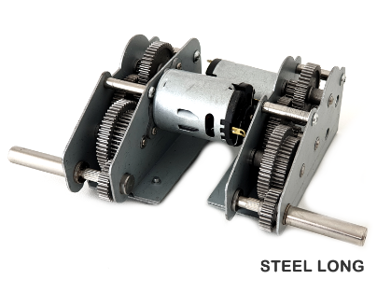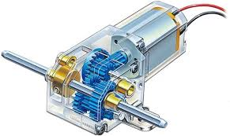**Why I picked this specific component:**

**I picked design two cause it has a more clean and metallic design while also providing more power through two motors while also having stronger and light gears to help provide the requirements of the solution**

**Arduino Uno Wifi Rev2:**

**Link:** [Arduino Uno WiFi Rev2](https://store-usa.arduino.cc/collections/boards-modules/products/arduino-uno-wifi-rev2?_pos=5&_fid=7377575b9&_ss=c)

**Description:** This Arduino board includes built-in Wifi capabilities, allowing for wireless control and communication.

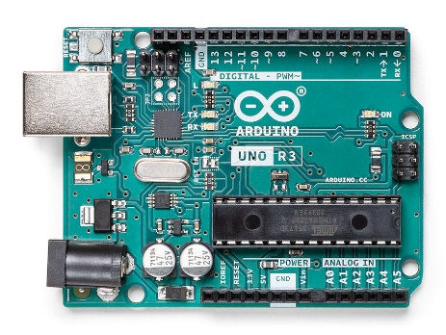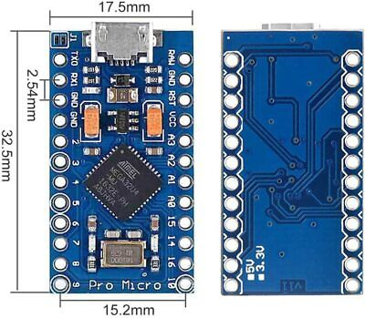**Why I picked this specific component:**

I picked design two which is the Arduino uno because it has more functionality and power than the 3rd party chip board while also backed by millions of library to help with the coding and heaps of community support

**Dual H-Bridge Motor Driver Module:**

**Link:** [Dual H-Bridge Motor Driver Module](https://www.makerstore.com.au/product/elec-l298n-motor-drv/)

**Description:** The L298N motor driver module is capable of controlling the direction and speed of two DC motors. It uses two H-bridge circuits to drive the motors and can be controlled via PWM signals from the Arduino.

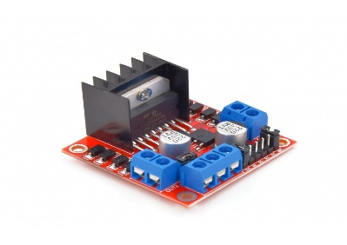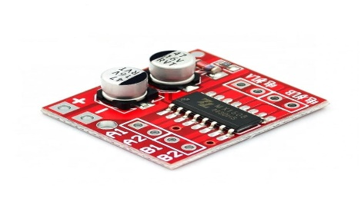**Why I picked this specific component:**

**I picked design 2 because it has more functionality and can provide more current and voltage to the motors well also dealing with the heat well with the massive heatsink despite that it is still lightweight and provides the requirements of the solution**

**Connecting Arduino to H-Bridge and Motors:**

**Project Hub Tutorial:** [Connecting L298N to Arduino and Motors](https://projecthub.arduino.cc/lakshyajhalani56/l298n-motor-driver-arduino-motors-motor-driver-l298n-7e1b3b)

**YouTube Tutorial:** [DC Motor Control with L298N](https://www.youtube.com/watch?v=7XUVm_eMsqo&t=4s)

**How to use PWM signals with H-bridge and other help:** [Arduino DC Motor Control](https://howtomechatronics.com/tutorials/arduino/arduino-dc-motor-control-tutorial-l298n-pwm-h-bridge/)

**Description:** These resources provide detailed instructions on wiring the L298N motor driver to an Arduino board and controlling DC motors using PWM signals. They include circuit diagrams, code examples, and explanations of how the H-bridge works to control motor direction and speed.

**Bluetooth Control for Arduino:**

**App Link:** [Bluetooth for Arduino](https://apps.apple.com/us/app/bluetooth-for-arduino/id1505096526)

**Arduino Library:** [ArduinoBLE Library](https://www.arduino.cc/reference/en/libraries/arduinoble/)

**Project Example:** [Bluetooth Controlled Car](https://projecthub.arduino.cc/samanfern/bluetooth-controlled-car-c71cd0)

**Description:** Use the Bluetooth for Arduino app to control your battle bot wirelessly. The ArduinoBLE library allows for easy integration of Bluetooth functionality in your Arduino projects, and the example project provides a comprehensive guide on setting up a Bluetooth-controlled car, which can be adapted for your battle bot.

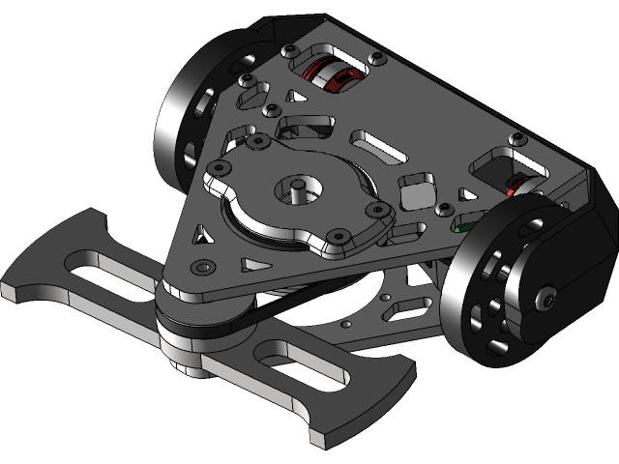***Design 1:***

As this system has a smaller chassis it won’t have the capacity to hold a bigger battery meaning won’t have as much power or speed as a bigger chassis bot because of reduction in battery size Which wont help with how long it can run for

Also a restriction with this design is that the entire battle bot system is made out of steel/metal which makes very costly and take more time to develop which can be a problem when running a low budget quick project as it might not fit the criteria and requirements.

***Design 2:***

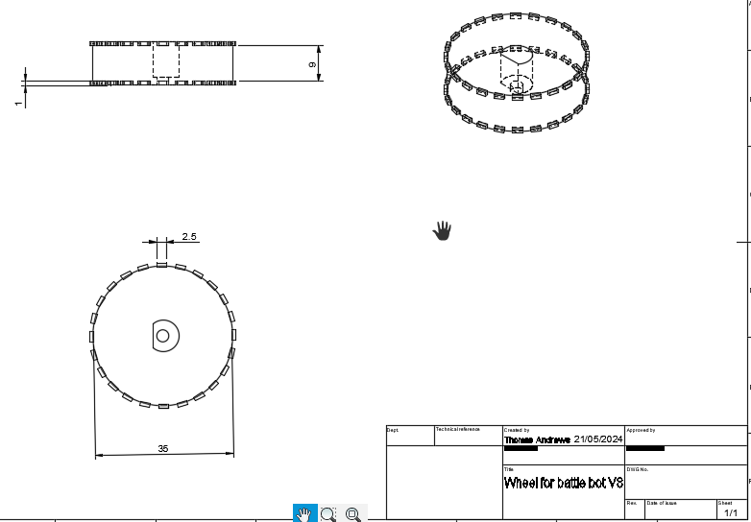As this design 2 only shows the base chassis design and wheel design that is because it follows design one pretty closely but with a bigger chassis to have space for a bigger battery and stronger armour, Provide with this additional upgrades to the other design it will have more power in the speed and the weapon with greater capacity battery, it will also run longer which will help satisfy the problem/need of this battle bot system.

**Preferred design:**

I pick design two as it fits the need/problem of the design brief despite it being larger, it will be still lightweight and powerful with speed but also not being time and cost driving as the design will be easier to develop then design 1 with it being complex steel design, So it will provide the solution to the problem/need that Im looking for.

|  |  |  |  |  |
| --- | --- | --- | --- | --- |
| Component Name: | Description: | Quantity | Supplier | Total cost: |
| **Steel Gearbox/Motor** | This component is what turns the wheels to the bot as it has a electrical motor attached to gears that will be connected to the wheels and turning | 2 | Ozarmour  [Steel Gearbox](https://www.ozarmour.com.au/store/rc-tank-parts/gearboxes/steel-gearbox-long-shaft-58mm-for-heng-long-1-16-rc-tank.html) | $50 * 2 |
| **Arduino Uno** | This component is what drives the logical in the battle bot as it will hold the logical code and output through wires signals to control the wheels and the spinner weapon | 1 | MrWeb  [Arduino Uno WiFi Rev2](https://store-usa.arduino.cc/collections/boards-modules/products/arduino-uno-wifi-rev2?_pos=5&_fid=7377575b9&_ss=c) | Free |
| **Dual H-Bridge Motor Driver Module** | This component will be responsible for controlling the input current from battery and connecting the gearbox/motor to the Arduino through the signal inputs connect from the Arduino to the h-bridge to the motor | 1 | Makerstore  [Dual H-Bridge Motor Driver Module](https://www.makerstore.com.au/product/elec-l298n-motor-drv/) | $7 |
| Bluetooth Arduino module | This component will be responsible for relaying signals from my phone/controller to the Arduino so that I can input signals to control the battle bot from a distance without touching the battle bot, it will useful for remote control of the bot | 1 | Mrweb | Free |
| **Wheels** | This component is what moves the battle bot and controls its direction as it is 3d-printed with TPU (rubber like material) tracks and PLA base rim to move the system effectively. | 1 | Me | Free |
| Battery | This component is responsible for supplying voltage and current to the whole electric system allowing the arduino and motors to be used and runned for a long timer | 1 | Fpvfaster | $100 |

**Risk Assessment:**

|  |  |  |  |  |
| --- | --- | --- | --- | --- |
| Stage/Item | Description of Identified Risk | Existing Controls | Risk Assessment | Preventative Action |
| 3D printing parts | 3D printer has hot nozzle and hot substance coming out of the nozzle which can reach temperatures higher then boiling point, These create risk of burns if touched. Also the printer has moving parts so loose hair or clothing can also be a risk hazard with it getting caught inside the moving parts and ripping. There also toxic fumes from the abs and nylon filament that can cause health problems | * The printer automatically cools down after a job done making low burn risk * The tip of the nozzle is covered by the head of the printer which covers it and makes it very hard to touch the hot surface | Extreme High Medium Low | -Reduce the time you are in the same room while it is in use  -Wearing thin protective gloves while using and touching the printer  -After every use check for damage on the printer and make sure everything is good  -Use printing materials that have less fumes or use the printers under air vents while on to help with fumes |
| Using LiPo battery for the power | Could exploded leaking harmful and flammable materials everywhere which could cause a fire or health problems for a person that inhales/touches the harmful materials.  Can cause electrocuted/short to a person that is using it | The battery wires are covered with nonconductive material that doesn’t allow current to flow to any other body.  Can buy LiPo battery sleeves that will protect the battery from causing a fire or explosion | Extreme High Medium Low | Make sure not to drop it or damage and always check after every use for damage  Store it in less flammable places where it can stop damage if it does go off |
| Laser cutting boards | Laser cut can harm or damage your eyes if you stare at the laser.  Laser cutter has a risk having materials catch on fire while cutting that can be a hazard.  Laser cutter can produce toxic fumes that can be harmful to the human body if not aware about | The laser cutter has a protective cover over the top to prevent fumes and light from the laser hurting you while also a vent for the fumes to be ale to open it up once it is done.  The laser cutter is built out of non-flammable materials reducing chance of fire breaking out | Extreme High Medium Low | Always keeping a fire exhauster near the laser cutter in case of a fire  Keeping the inside of the laser cutter clean and check it every use to prevent unwanted items to be in the machine  Wearing PPE on your body to make sure your protected  Do not look inside the machine while it is on and operating |
|  |  |  | Extreme High Medium Low |  |
|  |  |  | Extreme High Medium Low |  |

**Australian safety standard:**

**LiPo Battery:**

* **Don’t use LiPo that have signs of damage like denting/crushing, overheating, swelling, leaking, venting gas**
* **Also never over recharge the battery. It can cause excessive gassing that ruins the device, and it can also accumulate flammable hydrogen**

|  |  |  |  |
| --- | --- | --- | --- |
| Filament | Pros | Cons | Price |
| ABS | Tough; Common; Non-toxic  It is easy to shape and hard to break. While also being chemical and water resistant  Can be good to use for gear and moving or interlocked parts | High melting point;  Unpleasant fumes  Affected by UV light that can damage it, Not suitable for outdoor use | $20 to $50 |
| PLA | Easy to print with than ABS also Biodegradable  Tough and resistant material  Good for General printing and painted miniatures | Prints degrade over time; Rough texture, Water and chemical damage, also can be eroded away from bacteria | $20 to $50 |
| PVA | Water soluble; good for supports that need to be removed after for complex design prints. Good for printing complex models with PLA or ABS | Can release toxic vapours if overheated; Expensive; Requires appropriate disposal | >$100 |
| TPU (Flexible Filament) | Produces flexible prints, that can be used to replace parts that are rubber since it has similar properties to it. Good for covers for items and toys, | Requires modification of the printer or extruder | $50 to $120 |
| TPE78 | Good flexibility for applications that require stretching and compression without breaking.  Ease of processing using traditional thermoplastic processes.  Durability for use in demanding applications and harsh environments.  Cost-effectiveness, especially for high-volume production runs. | Lower melting point limits use in high-temperature applications.  Limited chemical resistance, especially with highly aggressive chemicals or solvents.  Some types of TPEs degrade or discolour when exposed to UV light, which limits their use in outdoor applications.  Some TPEs are difficult to recycle because they contain specific types of additives. | $40 to $60 |

|  |  |  |  |
| --- | --- | --- | --- |
| Microcontrollers | Pros | Cons | Price |
| Arduino Uno Rev3Arduino Uno | Wide range of language libraries to build all sort of things  Heaps of community support plus easy beginner friendly language to learn C++.  Steady 5v pins for connections to electric | Processor has limited memory and low processing power, which makes it slower than other microcontroller chips.  Can process only one task at a time as it has a single-core processor.    Don’t not have various connectivity options. | $>35 |
| Buy Raspberry Pi 5 Model B | 4 GB ...Raspberry Pi | Can be Used as a Portable Computer  Faster Processor  Supports all type of Codes (C, C#, C++, Python, Java, Ruby)  Multiple connection pins | Missing eMMC Internal Storage (slow read and write times plus slow boot times)  Overheating (doesn’t come with any heatsink but can reach temps of 70 degress) | $135 |
| ESP32  ESP32-DEVKITC-VIE Espressif Systems ... |  |  |  |
| BeagleBone Black  BeagleBone Black - BeagleBoard | Mouser |  |  |  |